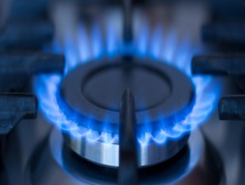 | 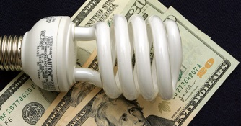
Low Income Oversight Board
WWW.LIOB.ORG

Vision
The LIOB will advise the Commission on ways to maximize the benefits of state and federal energy efficiency and public purpose program funding to lower the bills and increase health, safety and comfort of low income customers while reducing greenhouse gas emissions.
Guiding Principles

- The LIOB will balance the interests of low income customers, utility ratepayers and regulators in developing recommendations.

- The LIOB will monitor and evaluate the implementation of programs provided to low-income customers and assist in the assessments of low income customer barriers and needs to inform recommendations.

- The LIOB will encourage collaboration and leveraging multiple program funding sources to maximize the benefits of these funds to low income customers.
- The LIOB will encourage holistic solutions to make it easier for customers to participate in programs.

- Increase the benefits of clean energy programs in disadvantaged communities (e.g. by supporting growth in local employment and small business development, as well as other non-energy benefits including reducing pollutants and health risks).

- Increase access to clean energy technologies for disadvantaged communities.

- Maintain or enhance the affordability of energy service in disadvantaged communities, by considering potential rate impacts of any proposed program.
Mission

The mission of the LIOB is to advise the Commission on low-income electric, gas and water corporation customer programs and to serve as a liaison for the Commission to low-income customers and representatives.

