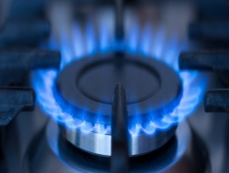 | 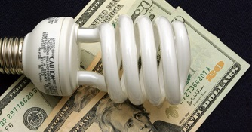
Low Income Oversight Board
WWW.LIOB.ORG

Vision
The LIOB’s vision is to maximize the benefits of utility, state and federal low income programs to improve the health, safety and comfort of low income customers while reducing energy consumption and greenhouse gas emissions.
Guiding Principles

- Stewardship: Balance the interests of low income customers, utility ratepayers and regulators in developing recommendations.

- Accountability: Monitor and evaluate the implementation of programs provided to low-income customers and assist in the assessments of low income customer barriers and needs to inform recommendations.

- Cooperation: Encourage collaboration and leveraging multiple program funding sources to maximize the benefits of these funds to low income customers.

- Communication: Encourage holistic solutions to make it easier for customers to participate in programs.

- Advocacy: Increase the benefits of clean energy programs in low income communities (e.g. by supporting growth in local employment and small business development, as well as other non-energy benefits including reducing pollutants and health risks).

- Promote Technology: Increase access to clean energy technologies for low income communities.

- Excellence: Maintain or enhance the affordability of energy service in low income communities, by considering potential rate impacts of any proposed program.
Mission
The mission of the LIOB is to advise the Commission on low-income electric, gas and water corporation customer programs and to serve as a liaison for the Commission to low-income customers and representatives.

