Public Input Workshop on the Joint Utility
Low Income Energy Efficiency
Pay-for-Measured-Savings Pilot Project
Policy and Procedures

Final Report

Held at:
Pacific Gas and Electric Company’s
Pacific Energy Center
851 Howard, San Francisco, CA
November 14, 2000
10:00 AM to 4:00 PM
and
Sempra Energy Company
101 Ash Street, San Diego, CA
November 17, 2000
10:00 AM to 4:00 PM

Report Date:
December 29, 2000
Table of Contents

I. Workshop Attendees 1
II. Workshop Operation 1
III. Workshop Discussion Summary 2
IV. Pilot Planning Mandates 6
V. Pilot Project Size 8
VI. Outsourcing Approach 13
VII. Measurement & Evaluation (M&E) 17
VIII. Design and Operations 22
IX. Past Experience 29
X. Additional Comments 31
Attachment A Public Notice
Attachment B Sign In Sheet
Attachment C Agenda
Attachment D Program Presentation Slides
Attachment E Workshop Handouts

Workshop Attendees
The public meetings posted through the service list (See Attachment A).
Representatives from the following organizations participated in the Pay for Measured Savings workshop held at the Pacific Gas and Electric Company (PG&E) Pacific Energy Center in San Francisco on 11/14/00: PG&E, Southern California Gas Company (SoCalGas), San Diego Gas and Electric Company (SDG&E), California Public Utility Commission – Energy Division (ED), Southern California Edison Company (SCE), Richard Heath Associates (RHA), QCS, Winegard Energy, SESCO Inc., Community Action Agency of San Mateo County (CAA), California Public Utility Commission – Office of Ratepayers Advocates (ORA). TELACU (attended via the telephone). A complete list of attendees that signed in at the workshop is presented in Attachment B.
Representatives from the following organizations participated in the Pay for Measured Savings workshop held at the SEMPRA Headquarters in San Diego on 11/17/00: PG&E, SoCalGas, SDG&E, ED, SCE, RHA, QCS, Capital State, Campesinos Unidos, Inc., MAAC Project, SoCal Forum, RER, SEMPRA Energy, Insulation Contractors Association (ICA). While there was indication of participants on the telephone (beeps), no one responded to questions from the facilitators. Therefore, it is not clear whether there was telephone participation during this workshop. A complete list of attendees that signed in at the workshop is presented in Attachment B.

Workshop Operation

The workshop on 11/14/00 followed the agenda presented in Attachment C. The morning session covered the Low Income Energy Efficiency (LIEE) pilot planning mandates, pilot project size, and outsourcing approach. The afternoon session covered the measurement and evaluation (M&E) protocols, pilot project design and operation, and prior experience with pay for measured savings. The workshop started at 10:00 AM, took a break for lunch from approximately 12:05 PM to 12:35 PM and adjourned at approximately 3:30 PM, having completed the agenda.
The workshop on 11/17/00 also followed the agenda presented in Attachment C. The morning session covered the LIEE pilot planning mandates, pilot project size, outsourcing approach, the M&E protocols and part of the pilot project design and operation. The afternoon session covered the rest of the pilot project design and operation, prior experience with pay for measured savings, and other issues. The San Diego workshop started at 10:15 AM (due to participant airline delays), took a hiatus for lunch from approximately 12:15 PM to 12:45 PM and adjourned at approximately 2:00 PM, having completed the agenda.
Both workshops were facilitated, recorded, and reported by Equipoise Consulting, Inc. The workshops were tape-recorded and the tape recordings are available upon request from SDG&E. Workshop presentations are included in Attachment D. Workshop handouts are included in Attachment E as a separate PDF format file.
The workshop developed a wide range of comments and positions and had robust participation from attendees representing a spectrum of organizations. While the discussions were often extensive and diverse, only the primary points are documented in this report. These points were recorded on flip charts during the workshop. Each participant was encouraged to review the written summary points and modify as they felt was necessary to accurately reflect their position. Time was allotted throughout the meeting to perform this task as well as at the end of the workshop. Each participant was made aware of the fact that the statements on the flip charts covered the main points which were going to be reflected in the written record.

Workshop Discussion Summary

The purpose of the workshop was to obtain public input on the design of the Pay For Measured Savings pilot projects. The workshop was held primarily to address Ordering Paragraphs (OP) 2 and 3 of CPUC Decision 00-07-020. Since the purpose of the workshop was to obtain and document public input, no attempt was made to reach consensus positions. Thus the views of various parties were documented, reflecting that some of these views are conflicting.
The body of this report presents, by agenda subject area, the input recorded by the workshop facilitators and reviewed by the workshop participants both during and at the conclusion of the workshop. The recorded input is presented by workshop date, in order to keep question and response comments in context. While the facilitator attempted to keep the discussion within the specific agenda topic, discussion often ranged to other associated subjects. In order to facilitate finding comments on the tapes, all comments were kept in their original sequence during the write up, regardless of topic.
The following summary paragraphs are intended to give an overview of what was discussed at the workshop. The detailed notes are presented in the relevant sections later in the report and should be reviewed to understand the contributions of the workshop participants.
Planning Mandates. This part of the workshop set the stage for the pilot design discussions and garnered few comments from the workshop participants. It highlighted the points of the decision relevant to the pilot project.
Pilot Size. While not directly related to pilot size, a question was raised about exactly what is supposed to be tested by these pilots. Are they going to be an assessment of the value of the measures installed or the measure delivery system? The utilities stated that they felt the pilots are supposed to test a different way to pay service providers for installing the same measures (i.e., pay based on customer bill savings versus the contracted cost of measures installed). A difference of opinion was noted between some of the contractors present and others attending the workshops regarding which measures should be installed under the pilot. This contractor group felt that the pilots should allow flexibility and should allow them to install not only all feasible measures listed in the statewide Weatherization Installation Standards (WIS) manual, but also other measures that the WIS does not allow. The utilities, ORA, and community based organizations (CBOs) felt that only measures that are currently offered under the regular LIEE programs should be allowed in the pilot to assure that customers participating in the regular programs and the pilots receive equal levels of service. Also, by holding all other aspects of the LIEE programs stable (such as the mix of measures installed), the payment mechanism variable can be better tested, and the pilot results will be applicable to the regular program.
On the subject of pilot size, workshop participants stated that similar physical areas and housing types should be used by each utility. By doing this, the transferability of the pilot may be assured. Concern was expressed about coordination between the various programs in the field (i.e., state, utility weatherization, and pilot).
Outsourcing Approach. The workshop participants felt that the current contractors should get first preference in fielding the pilot, but that they should be trained in providing this type of project if they are inexperienced. Several contractors suggested that the pilot be opened up to other contractors if the current contractors do not show enough interest in the pilots or cannot weatherize the number of homes targeted for service under the pilots. The need for a mechanism to ensure 100% effort by the service providers participating in the pilots was identified. Additionally, one of the contractors expressed a need to know in advance which way they would be paid before they go into a home because it may affect the measures to be installed.
Measurement & Evaluation Protocols. The workshop participants had different approaches to assessing bill savings. Several independent installation contractors felt that the reference in the pilot project measurement & evaluation (M&E) following the CPUC adopted Annual Earnings Assessment Proceeding (AEAP) meant that the pilot should use deemed savings estimates to identify and assess customer bill savings. Many other participants, including utilities, CBOs and state agencies, interpreted the reference to AEAP methodologies to refer to the “Protocols and Procedures for the Verification of Costs, Benefits, and Shareholder Earnings from Demand Side Management Programs” (Protocols). These Protocols generally require detailed post-installation measurement and assessment of program impacts. Further, there was much discussion about whether and how assessment of low-income customer hardship would be evaluated for the pilot. While there was no consensus on whether deemed savings or the adopted AEAP Protocols approach should be used, it seemed to be generally agreed that Protocol based assessment would mean post-installation data accumulation and monitoring, which would take at least a year after installation. There seemed to be agreement that M&E should be done by someone other than the installation contractors. Much discussion occurred, with little resolution, on how the M&E assessment could be coordinated with timely payment of contractors. The option of utilizing a split contractor payment schedule was discussed.
Pilot Design & Operations. The design and operation discussion mainly centered on which measures could and could not be installed in the pilots. Some felt that the pilots should test how to pay contractors based on customer savings accrued due to the LIEE program, including only the current LIEE program measures, policies, and procedures. This camp felt that the results of the pilot needed to be directly applicable to the current LIEE program. Others felt that the pilot should allow contractors to use their discretion and install, in addition to the mandated measures, all the measures (including non-LIEE program measures) that they believe will save energy, then pay the contractor based on the resulting savings. This group felt that that pilot has the authority to go outside the LIEE program measures, policies, and procedures offered under the current LIEE program. The primary differences between the two approaches are (1) the potential effect on non-equity across all low-income participants in terms of the services received, and (2) the resulting applicability of the pilot to the current LIEE programs. Outside of these issues, there was much discussion, and some agreement, on the specifics of implementing a pilot program in California.
Prior experience with pay for measured savings. Discussion of background data identified several additional sources of information to be studied. The pay for measured savings pilot planning team was cautioned about the necessity to analyze the reports of prior studies because the results were highly dependent upon whether or not contractors were given freedom to install all measures that they believe would save energy. In addition, it seemed to be generally agreed that the search of other program studies should initially include all program sectors, then rank and screen them in order of relevance to the current study.

Pilot Planning Mandates

Donna Wagoner of the Energy Division provided an overview to the mandates in effect for the pilot design for the 11/14/00 meeting while Jonathan Tom of the Energy Division did so on 11/17/00. It was stressed that this was not a forum to discuss the merits of a pay for measured savings pilot program since it has been decided that such a pilot will occur. The parts of the decision specific to the pilot were:
- The pilot should focus on demonstrable bill and energy savings, not just the number of measures installed in the customers home.
- The pilots should help the commission in evaluating the potential in incorporating the measured savings into the payment structure for the contractors working on the LIEE program irrespective of whether selected via competitive bidding or other outsourcing means.
- The decision directs that the pilot project size should be meaningful and should cover a specific geographic area in each utility service area but it is limited to 10% of each utility’s program in terms of units treated.
- Measurement protocols need to be developed through this process, or the joint utilities may propose using the measurement protocols used for the AEAP.
The handouts provided at the meeting are included in Attachment E. If the utility or energy division representatives answered direct questions from others, their responses are shown in italics.
Documented Workshop Input
The following comments were received during the San Francisco workshop on 11/14/00.
- Could you elaborate more on the project size in respect to each utility? (QCS)
They were pretty clear that it can’t be more than 10% of the total number of units treated by a single utility. - ED
- There are 17 climate zones in California and each impact usage, will this pilot address the variances in climate? We feel that it does need to be addressed. (RHA)
The Statewide LIEE Program Standardization Project Team has recommended that the Commission adopt a five climate zone model, tied to recommended statewide insulation level guidelines. The five climate zone model may also be used for the pilot projects. (SDG&E)
- Will there be more than one operator of the pilot in each utility? (CAA)
It needs to be worked out in this process – ED
The following comments were received during the San Diego meeting on 11/17/00.
- What is the goal of the pilot? Is it to provide greater bill savings to the customer? (QCS)
This pilot is to figure out how to better pay the contractors, not to introduce new measures with increased performance. That [performance of measures] is being done under another project. (PG&E)
The decision speaks for itself. It is to test the efficacy of paying contractors in the program based on actual bill energy savings. The decision does not say to change the mix of measures we currently provide in the program or to change any other variables. The whole reason to do a pilot is to test a variable and the variable we’ve identified to be tested is payment based on bill savings. (SDG&E)
[That is] based on the approved measures in the program now, not new measures. (PG&E)
- We feel that if it is to test payment based on actual bill savings under the LIEE mandates, there are several LIEE mandates that should be met. They are: 1) focus on customer safety 2) control their energy usage based on energy education 3) increase customer health, 4) increase customer safety, 5) meet terms of conditions of AB1393, 6) stimulate local economy, 7) promote utility good will. The pilot needs to work within the context of those mandates. (RHA)

Pilot Project Size

Jack Parkhill of SCE provided slides to lead the discussion on pilot size. The main points of his presentation covered the ordering paragraph, which was reiterated to focus the discussion on what this topic covered, and certain issues around pilot size that the Pay For Measured Savings (PFMS) Planning Team had come up with for the workshop to consider. Among these were the geographic regions, climatic conditions, actual size of the pilot, and other issues.
The slides presented during both workshops are presented in Attachment D.
Documented Workshop Input
The following comments were received during the San Francisco workshop on 11/14/00.
- What are we testing? Is it the stand-alone value of the measures versus the measure delivery system? Stand alone measure testing could focus on the appropriateness and persistence of the measures. If the delivery system is being tested, then it should address multiple variables like marketing, installation, inspection, et. al. that comprise the cost of installing the measure. (RHA)
- Do we want the pilot distributed over large geographical area or focus on one or two area/geographic regions? (SCE)
- SDG&E has had a smaller geographic area and a program that has been operating for 20 years. Much attention has been paid to specific areas with high concentrations of LIEE eligible customers. Should the pilots be done in these areas or in other areas with potentially fewer low income customers? (SDG&E)
- The pilot area should be similar to the current areas (as much as possible) so area cannot be used as a reason the pilot did or did not work. Is the plan to run the pilot in the same area as LIEE programs or “franchise” territory where the pilot is to be run? Depending on how it is run, these have different concerns. We feel that the pilot could be run in the same area as the other programs. The pilot should test one aspect of the program but keep other aspects the same. (SESCO)
- If you are having one agency doing the pilot, then there will be other programs going on in the same area. Coordination is a concern between the various programs (i.e., state, pilot, and utility weatherization programs). (CAA)
- PG&E feels that the pilot does not need to be isolated, but must be transparent to the customer. It is the payment and evaluation of the program that is different. We do not advocate different vendors presenting different programs, just isolating an area and paying/evaluating that area differently, but doing the same program. (PG&E)
- SCE believes that the service delivery mechanism (i.e., referrals) can be a cross-pollination between the various programs. (SCE)
- We feel that there may be difficulty with overlapping programs since pay for measured savings may not install all the measures that the non-pilot program would get and may hurt the customer. Historically pay for measured savings type programs allow installation of various measures. We agree with following the Weatherization Installation Standard (WIS) standardization manual for measures within it, but the contractor needs to be able to determine which measures to install in a pay for measured savings program. (QCS)
- Can the client get both services if there is an overlap between the pilots and other utility weatherization programs? (CAA)
- The ORA expressed concern with what they heard - that the pay for measured savings may discriminate based on how the program is marketed (i.e. pilot and other programs) and that the pay for measured savings pilot may not install all feasible measures. (ORA)
- We agree with the ORA that we should not discriminate, The pilot needs to be comprehensive and fair to the customers. The need is to determine how to measure this. (PG&E)
- If a pilot like this is a bad idea, it should be implemented at 1%, whereas if it is a good idea, it should be implemented at 10%. The WIS Manual states that all feasible measures must be installed and we agree with this. However, the pilot should be able to allow more flexibility and comprehensiveness to the contractor (e.g., could install lights that run less than 4 hours per day or add attic insulation even though there is R11 already in the household – two things that cannot be done according to the WIS manual). (SESCO)
- We agree with SESCO that if there are other measures there, we could do more under the pilot. We have found that we do a more comprehensive approach and do more measures in the past when doing a pay for measured savings type of program (Winegard Energy)
- There are issues that affect the pilot size: 1) number of utility programs - are all utility programs included since there are different number of programs by utility; 2) 5% of a 35,000 goal or 10% of 24,000 goal? 3) percentage required by climate zone since may service a portion of their territory based on climate zone? 4) housing stock, older/newer, single family/multifamily, housing units. (SCE)
- The utility should not place the size so small that only one contractor runs the pilot. We recommend multiple contractors be used for the pilot (at least two). Set the pilot program contract size to be large enough, but not necessarily based on percentage of dwellings that is the same for each utility (e.g., one utility may have 10% of their dwellings in the pilot while another has 5 or 6%). (SESCO)
- It is difficult to administrate and evaluate the pilot if there are multiple contractors. In considering the pilot, it may be an option that each utility operate specific pilot projects. (SCE)
- Where the pilot is being operated is a factor. How are the economics of urban versus rural being factored in to the pilot size and how is that information going to be used in this package? (CAA)
- We want to be broad enough to incorporate the whole environment. Possibly it should be offered to all the contractors who want to participate in the pilot, and then at the same time capture single family/multi-family/ mobile home and rural/urban and climate zones because all [the contractors] have different travel time and pricing structures. We could incorporate all that into the pilot and track it. We must stay within a strong enough representation of sample size, too. (PG&E)
- We are talking about 10% of the existing homes and budgets, not increasing the budget, correct? (SCE)
- We are not advocating an increase in budget, but to use 10% of the existing units to be serviced under the existing program. (PG&E)
- If you choose to do the pilot in only one area, there may be difficulty in making judgement calls as to whether the pilot project results are transferable (i.e., from urban to rural or single family to multi-family). (SESCO)
- The cost of living in urban San Francisco and Fresno (or any city in the state) varies – how is the pilot planning to deal with this? What is the cost of doing business? We don’t believe that you can come up with a one size fits all. (CAA)
- If the pilot shows that it works better in rural or urban due to issues brought up by CAA, that begs the question as to fairness for the customer, if one customer is getting more in one area than another then that could be a problem. (PG&E)
- We are not testing whether the people are equally served in this pilot (equity issue) – there are laws that deal with that. We feel the pilot is to test the cost effectiveness of the measures installed. (RHA)
- The pilots are to determine if there is a different way to pay service providers for installing the LIEE measures (i.e., pay on customer bill savings versus contracted cost of measures installed). The question is not can you vary how you install measures or can you install more or less measures than the program is set up to do. Program rules regarding adding new measures or deleting existing measures is being dealt with elsewhere. We agree that we should hold other aspects of the regular LIEE and pilots stable to test the payment mechanism variable. (SDG&E)
- We disagree that pilot is to see if you could pay contracts a different way. If the payment mechanism is different, does it improve services to the low income customer? This is the actual question. (SESCO)
- If the pilot wants to cover multiple housing stocks and geographical areas, then we believe that offering it to current contractors to see if they will take on the added burden of the pilot is the only way to go since we wouldn’t want multiple contractors butting into each other in the field. (PG&E)
- How will savings be measured (evaluated) when installing different measures under different programs? (QCS)
- The AEAP is mandated for the pilot– not meter level evaluation, but deemed savings by measure with no interaction assumption, so you can separate out different programs. (SESCO)
- We recommend letting current contractors apply pay for measured savings type of payment to a percent of existing work. We recommend keeping to the weatherization contract level, not different contracts for different programs, so there is comparability between utilities. (SESCO)
The following comments were received during the meeting in San Diego on 11/17/00.
- There are several factors to consider in the pilot size such as high density of multi family units, age of the house, household size, and language issues. (RHA)
- The PUC is working with utilities on the LIEE standardization project covering statewide LIEE program activities. There is a proposal that five climate zones be used for the statewide LIEE programs. The pilot project designs may adopt this approach as well. (SDG&E)
- There are other standardization projects on-going and we will coordinate with those as much as possible and adhere to their decisions. (ED)
- You need to have a good mix of homes (mobile homes/ single family / multi-family) so you can say didn’t leave anything out once the pilot is over. (QCS)
- Is the cost of gas or electricity in the service territory be taken into account? (RHA)
This is not a consideration in the pilot size. It probably comes into play in the measurement and evaluation of the program. (SCE)

Outsourcing Approach

Lou Estrella of SoCalGas posed several questions around outsourcing approaches to stimulate interactions and solicit answers and input back to the utilities and commission. He brought up the ordering paragraph that was relevant to this issue where it states, “The pilot may be conducted in conjunction with a competitive bid or may be proposed in conjunction with a different outsourcing approach.” This moved directly into the main question of how the utilities should select the service providers to field the pilot projects. Overheads from the workshops are included in Attachment D.
Documented Workshop Input
The following comments were received during the San Francisco workshop on 11/14/00.
- The word “provider” needs to be defined. We propose two different types of providers: 1) energy saving services provider and 2) M&E provider that measures the bill savings of houses that have passed utility post-inspections (this should be an independent third party). (RHA)
- The pilot is currently proposed to use current LIEE contractors who are trained in LIEE programs. (PG&E)
- We did a similar type of piggy backing of pay for measured savings and a regular program delivery for SoCalGas about four years ago. There was difficulty with this and it ended up that all the jobs we did on Tuesdays were pay for performance homes and all the other days the homes were on the regular program because there was no clear way to determine which houses should be pay for measured savings. (Winegard Energy)
- If we try to get a comparison of different payment schemes, the contractor should not get to pick payment schemes (i.e., under the pay for measured savings or other programs.) (SCE)
- The contractor needs to know ahead of time which way they will be paid when they go into the house. The contractor needs to walk into the house and say, “This is a pay per measured house and so I’m going to approach this house a little bit differently than I would a different house. I might install a different type of measure or more measures than I would have because I see potential savings.” (Winegard Energy)
- There needs to be a provision to force homes to be done under the pilot program. Do not leave it to choice (e.g., first 100 homes or second 100 homes are under the pilot if they have to do 1,000 homes). We feel that the balance of the pilot program (if there is any) should be offered to current non-providers with experience and a desire to do the pilot. (SESCO)
- How will AB1393 be included in all areas of the pilot? (CAA)
The pilots are a sub-program of the LIEE programs and logic dictates that the pilots will need to comply with AB1393. Currently it is planned that the pilots will use the statewide weatherization installation standards manuals and the pilots will install the same mix of measures as the regular program which are covered by that manual. (SDG&E)
- We agree with points made up to now as far as how to select providers, but how to deem the values of measures installed so they make sense? (RHA)
- Is the contractor that is installing the measures also the contractor that is determining measure savings? Are they carrying both roles? (CAA)
We anticipate that the implementer and evaluators will be different people. (PG&E)
- Existing contractors don’t want others in their territory, so they may bid on the pilot, but don’t know how to do it. We feel that experience is essential in the choice of providers (or you should teach them if not experienced) or the pilot may fail. On another issue, we feel that the pilot falls under AB1393 auspices – is this a better way to provide services to low income customers? (Winegard Energy)
- If it is the choice to use the current contractors, you need to make sure that they give the pilot a 100% effort. (QCS)
- We advocate keeping the pilot small (i.e., 1% of homes) to assure success. (CAA)
- Existing service providers can do the pilot if 1) you establish training and inspection protocols for installations for this process and 2) if you only look at past post-installation work. (RHA)
- Set the payment to pay for measured savings lower that the current payment (e.g. 90%), but allow existing contractors to sign up first for 10% of their quota and will make it up by being more comprehensive. At the same time, select other contractors to use in special circumstances to help take up the slack, if other contractors do not make their goals. Use a different selection process for these other contractors, and let them tell you the current payment rate that they are willing to work for. (SESCO)
- The existing contractors can propose for the pay for measured savings pilot. If chosen, they should be held accountable for that. We feel the existing contractors should get first choice. If they don’t want to, that area could become open to other providers. (Winegard Energy)
The following comments were received during the meeting in San Diego on 11/17/00.
- Is it just weatherization measures in the pilot or the full spectrum of LIEE services (i.e., refrigerators, education, etc.)? (RHA)
It probably is the full spectrum, but the decision is not yet made on this issue by the team. (SoCalGas)
- We believe it is natural to use existing service providers. (RHA)
- We agree with RHA. We feel it gives the pilot the best chance of success to use the current service providers. Don’t want to force providers, though. Approach the current providers and give them the option to choose to participate in the pilot. (QCS)
- We feel that the existing players need to be involved and that the payment mechanism should be consistent with the goals of the pilot and not violate the existing codes that drive the LIEE. (RHA)
- However the contractor is selected for the pilots, we need to avoid conflict in the field between crews, avoid customer confusion, and assure the same level of service and mix of measures in the pilots as under the regular program. (SDG&E)
- Once the pilot size is decided and a percentage of homes is determined, it is important to allow contractors to volunteer. We then aggregate the number in the pilot across the contractors. This should help get good representation across regions and housing types. (PG&E)
- What mechanism is in place to avoid cherry-picking of customers? Should the option of home selection in the pilot be given to the contractor or should authority be given to the utility? (SoCalGas)
- If we offer these services through the current providers and current contractors and perhaps monitored the results after the fact, there would have virtually no difference in the program and none of the cherry-picking problems and it would be a true 10% cross section. (ICA)
- The guidelines state a comprehensive approach to serving homes and all feasible measures need to be installed. We do feel that if the contractor goes in under the LIEE program, he shouldn’t be able to install measures under other programs (i.e., the summer initiative) (PG&E)
- What difference does it make to contractors if you know going into the home that it is being treated as part of the pilot or just a normal home under the program? (SoCalGas)
- As a contractor, it depends on how we were paid for measures that have energy savings, preserve housing stock, or increase energy use. That would drive our decision. We assume pilot may be a blind situation where the contractor does not know how they would be paid. (RHA)
- If you do the standard measures under the pilot, the homes will save varying amounts of energy. If the home saves more energy, will the contractor get increased payments for that home? (QCS)
The contractor may be paid same or more – we trying to determine if the pay per measured savings is a better process than we currently have. (SoCalGas)
- We assumed that this pilot was for customers never in LIEE, above the income guidelines and want to pay for this pilot – is this true? (MAAC Project )
No, this is not true. (SoCalGas)

Measurement & Evaluation (M&E)

Mary O’Drain of PG&E provided the introductory remarks on M&E.
The following primary points from Decision 00-07-020 were emphasized:
- “The utility and contractor shall agree on measurement protocols that are consistent with those we have already adopted in the Annual Earnings Assessment Proceedings (AEAP), or with modifications thereto that we approve for the purpose of this pilot.”
- “We find considerable appeal in the concept of paying contractors based on bill savings, rather than solely on the number and type of measures installed in each home.”
- “It is reasonable to initiate a pilot to implement and test an approach that directly measures the achievement of this goal.”
- “The goal should be to enhance our ability to directly demonstrate bill savings for low-income customers through energy usage reductions.”
The presentation then went on to pose questions about measuring bill savings, contractor payment schedules, and development of M&E protocols, and to list other relevant evaluation efforts that are currently underway.
The slides presented are provided in Attachment D.
Documented Workshop Input
The following comments were received during the San Francisco workshop on 11/14/00.
- We heard that individual home tracking of energy bill savings is difficult, SPC has sub-metered energy consumption payments tied to this. Can the SPC format work here? (SDG&E)
- Deemed savings has had much discussion and no resolution. We need to de-couple payments to contractors and what the deemed savings are. (RHA)
- Hardship needs to be included as well as just bill savings. (PG&E)
- It is clear in the order that AEAP protocols are to be used, this means deemed savings and deemed measure life. These are not subject to tune up. We don’t have the flexibility to change this. The SPC approach does not follow the AEAP and would limit the contractors that could do the approach. (SESCO)
- AEAP protocols were assumed to be the Protocols [California Demand Side Management Protocols], which are based on measured billing analysis and measurement protocol, not deemed savings which is essentially what we do now in LIEE. (SCE, PG&E)
- The only way to determine the savings is through post-installation M&E. (RHA)
- Any information on measure savings needs to be incorporated into the measure assessment mechanism currently being developed by the statewide LIEE program standardization project. (SDG&E)
- Are we saying that there will be an evaluation being done as the pilot proceeds, so there is no lag time afterwards so that we can really understand what came out of the pilot? (CAA)
We assume that the evaluations will be after the pilot is completed, maybe using billing analysis, which may be as much as a year after the last home receives its measures. (PG&E)
- The issue is how much kWh and therms can be saved by measure. (RHA)
- If the purpose of the program is to determine what is being saved, and the payment is not dependant on what is being paid to the contractor, then why are we even doing a pilot? We could do it from the data we have now. (Winegard Energy)
The ALJ mother-in-law test suggests that this pilot should be about what the savings on the bill is, not what the contractors are being paid. (CAA)
- The ALJ indicated that the pilot needed to address how the contractors could be paid in a timely manner. We don’t see how, without using deemed savings, this could occur. If payments are stretched out very few contractors have the capability or sophistication to participate in the pilot. (SESCO)
- It seems to me that the pilot is the opportunity to actually measure the energy saved by the measures installed. (RHA)
- The more we review the decision, the more it seems to say pay for individual household savings. How do we tie actual customer bill savings to the payments to providers for the work performed at the house? (SDG&E)
- How do you know which measures are providing what amount of savings? (CAA, QCS)
- We suggest possibly 50% of deemed savings paid up front and then pay the balance after a true-up based on bill savings measurement. (PG&E)
- If the pilot is set up to pay based on post-installation M&E, then you can’t put in measures that repair or replace non-working equipment, because these would increase the bills. (CAA)
- How should we handle payment for measures that increase energy use since the LIEE program is required to install these measures? (SDG&E)
- We advocate program design based on deemed savings only with no impact evaluation to determine payment to contractors. Non-energy measures would be included in the base payments, or the program would pay differently for the energy and non-energy measures. (SESCO)
We do not feel this approach meets the needs of the pilot projects as stated in the decision. This undermines the concept of pay for measured bill savings, because it is paying for measured savings produced by some measures but not by all measures installed in the home. We suggest an approach where the contractor is credited for positive energy saving and is debited for negative energy savings and then paid based on the net savings. (SDG&E)
- How is hardship to be included in a deemed savings approach? It needs to be included somehow. (CAA)
- The big unknown is the kWh/therm savings, however a diagnostic process to determine the savings is expensive. If we use the deemed savings approach we need to be sure to develop an approach that makes sure the contractors don’t “game” the pilot. (RHA)
The following comments were received during the San Diego workshop on 11/17/00.
- These are public purpose programs dealing with equity issues. The societal benefits cannot be ignored during this pilot. This sounds more like a DSM analysis. (RHA)
- If we are using the AEAP protocols, societal interests have nothing to do with the measurement of savings themselves. There are other efforts underway to discuss a cost-effectiveness test that will incorporate hardship. That test will not be ready for a few months. In general, that wouldn’t be how you measure savings at the home. Perhaps we should talk about that since hardship is not in the current AEAP protocols (PG&E)
- We feel that the low-income program is not aimed at energy efficiency solely. (RHA)
- Contractors may have difficulty waiting for payment while M&E goes on. There needs to be some provision for up front payments to contractors during this period. (QCS)
We agree with this (as does the Commission) and it needs to be worked out. (PG&E)
- It is important to understand that this M&E will be different, since it is based on net bill savings realized by the customer – we need to take into account all things on the customer’s bill. (SDG&E)
- You need to understand that there are two components to M&E for the pilot – there is a difference between measurement and verification and measurement and evaluation. We need to: 1) verify the savings the contractor earns in order to construct a payment structure based on bill savings and 2) the pilot needs to be evaluated to see if it is successful. We should set up design so we can tell if it is successful in order to use this scheme in the future. It is more than just measuring bill savings, we need to evaluate the performance of this mechanism of payment for LIEE programs. (SCE)
- If it is just a measurement of just bill savings, are we talking about kWh/Therm savings? The LIEE program may not actually have savings, but we do not feel that this is the purpose of the program. (SoCal Forum)
This is dealing with net bill savings and paying the contractors in some way that deals directly with this savings. (SDG&E)
- Maybe we should be switching the focus of the project and focus on kWh/therms saved, not bill savings per se since bill savings are predicated on energy savings. They would have been paying more on their bill if they had not been included in the program. Regardless of the dollar amount saved on the bill, it’s energy savings that we need to focus on. (PG&E)
- We feel that clarification is needed from the ALJ on this if we want to make a such a change – to change parameters of the pilots, we may need to do a filing. ED had asked the ALJ for clarification on this and the ALJ stated that the utilities could provide two options when they propose the pilots: 1) based on measured bill savings and 2) based on measured savings achieved by weatherization of that home. (SDG&E)
- We recommend that bill savings be predicated on energy savings and make that clear in the proposal. (PG&E)

Design and Operations

Don Wood of SDG&E led the discussion on this topic. There was no formal presentation (and thus no slides provided) during the meetings. However, the questions same were asked of both workshop in series, and responses elicited from the workshop participants for each question. The questions are presented below in bold, followed by bulleted comments on question. Where an initial workshop participant comment lead to a reply response (or a back and forth discussion) these responses are presented in italics with a further indent.
Documented Workshop Input
The following comments were noted during the San Francisco workshop on 11/14/00.
Does the decision call for testing whether paying contractors based on measured net individual household bill savings produces positive program savings? (SDG&E)
- We feel net individual savings are not mentioned in the decision. (SESCO)
We disagree with SESCO and feel that the bill savings does need to be incorporated - citing the decision which says the appeal is on “the concept of paying contractors based on bill savings rather than solely on the number and type ...etc.”. Also, we must develop a means to incorporate bill savings in contractor payment. So, the team must find a way to marry AEAP concept of deemed savings with bill savings concept. (SCE)
How long should the pilots operate - 3 months, 1 year, longer? (SDG&E)
- We advocate for a 1 year pilot, with any evaluation conducted after the pilot is complete. (SESCO)
- We feel that the evaluation should be conducted after completion of the pilot. (ORA)
- We feel that it will be necessary to have one full year after of data collection for the pilot to be properly evaluated. (SoCalGas)
- Shouldn’t the amount of funding available for the pilot also affect the length of the program? (CAA)
Should pilot funding come from the regular LIEE program budgets or other sources? (SDG&E)
- Funding for the pilot comes from regular program funds, as all pilots have in the past. Program funding was finally defined at 10% of the units in the program. (PG&E)
Should pilot projects be required to comply with AB 1393? (SDG&E)
- Consensus from workshop participants indicated that it should comply with AB 1393.
Yes. (SESCO)
Should the pilots program outreach differ from existing LIEE outreach? Should the standardized outreach protocols be used for the pilots? (SDG&E)
- The pilot needs to assure equal treatment with that provided to other customers participating in the regular LIEE program. (ORA)
- The pilot needs to be comprehensive for each house. It should follow the WIS manual and program policies and procedures. (PG&E)
- We concur with the result (i.e. comprehensive treatment) but differ on the reasoning. A pilot means that it can be different than usual. We support equivalent outreach compared to the LIEE outreach approach. (SESCO)
- Allow contractors to do work as usual and have another contractor deal with evaluating pilot results. (RHA)
Should pilot customer qualifications and verifications differ from the regular LIEE program? Should verifications rules differ from the regular LIEE program? (SDG&E)
- No. (PG&E)
General consensus of the workshop was no to this question.
Should the pilots projects be designed based on the statewide WIS manual? (SDG&E)
- Yes. (PG&E)
- WIS manual is the minimum guideline, where the pilot allows exceeding the minimum then new guidelines are needed. (SESCO)
- We don’t think new measures are allowed, by our reading, but possibly expansion of current measures. (PG&E)
- A pilot means something different, so it should be OK to do it differently and maybe do different measures (e.g., duct sealing). The pilot should see how we can get the biggest bang for the buck. They will all get the basic measures, some will just get more than the standard. (Winegard Energy)
We disagree. We have been working to standardize measures and need to test the cost effectiveness of delivering the same measures under a different compensation scheme, not adding new measures. We need to be comparing apples and apples. (PG&E)
- A policy decision is necessary to decide which measures should be installed, standard vs. the measures that would maximize energy savings. These program approaches are considerably different. (RHA)
How should pilot implementation and reporting be coordinated? (SDG&E)
- We need to work with an independent contractor to evaluate the program, develop sound method of sampling and tracking of measures. Potentially the pilot should pay some customers extra just to be in the pilot (i.e., only getting one specific measure installed and measured). (RHA)
- We agree that customers could be paid for this kind of participation as long as the customer was paid the incremental difference that they would have saved on the other measures during the pilot, and then the pilot went back afterwards to complete installation of the remaining measures in order to make the customer whole and the program guidelines for comprehensiveness are met. (PG&E)
Should pre- and post-installation practices for the pilots be different than LIEE? (SDG&E)
- No. (PG&E)
- We may need to vary practices to accommodate new measures if they are installed. (SESCO)
- This all ought to be addressed by professional evaluators as part of a comprehensive assessment approach. (RHA)
The following comments were received during the San Diego workshop on 11/17/00.
What should the goals of the pilot projects be? (SDG&E)
- The goals are bill savings, energy savings, and [reduction of] hardship. (PG&E)
- We should quantify and assign value to comfort, safety, customer satisfaction, ability to understand energy use and how to control it, and other societal benefits. (RHA)
- We agree and are looking at trying to quantify energy hardship issues through another group. There is coordination between these groups. (PG&E)
How long should the pilots be operated? How long for M&E? (SDG&E)
- We need some other evaluations to be completed and identify and define some aspects of the pilot from those evaluations prior to starting the pilot. We may not need to start the pilot on January, 2002. We should run the pilot for a year and allow adequate time for evaluation. We are talking completion in 2004. (PG&E)
- M&E should look at how pilot affects things like terminations, arrearages, and disposable income for nutrition. While these are getting out there, these are the things that matter to low-income clients. (RHA)
- This pilot is looking at the efficacy of paying for bill savings, other evaluations in other venues are designed to look at those other things. (SCE)
- We need to take size of allotment into account for when M&E takes place so the contractor is paid expeditiously. We suggest staggering when the evaluation starts based on when the installations are complete. (QCS).
- The evaluations are based on when the last home is installed with delay of 1 to 1.5 years before the evaluation is final. We need to work out how we can protect the contractor from extensive delay in payment. (PG&E)
- Potentially we could handle this by not giving any one contractor a major fraction of the pilot so that the payment for the pilot only represents a small portion of their total receivables. That way the contractor doesn’t have a major hardship. (SCE)
- Suggest we pay full quoted price and track as if paid some percent now and the balance later and present to the judge as if paid this way. This provides the judge with pluses and minuses of this approach without creating a hardship for the contractors. If we do that we could launch the pilot program much quicker. (PG&E)
- So the pilot is invisible to the customer and the contractor? (i.e., it doesn’t affect daily activity of the contractor) (QCS)
Yes. (PG&E)
Should customers receive the same level of service and same mix of measures, and use the WIS manual?
- Yes, need to get same level of service, same measures, and use the WIS Manual and Policies and Procedures (P&P) for the program. (PG&E)
Some measures may increase consumption. How will these be dealt with? (SDG&E)
- We need to make the ALJ aware that there are energy savings and hardship measures addressed under the pilot. We should emphasize the importance of the energy savings part of the assessment to the ALJ. (PG&E)
- We feel that it is important to break up the mix – separate measures that increase consumption since this may affect bill savings and contractor payment. Also, we support previous idea that we may want to pay customers to install a single measure, then come back later and install remainder of measures. (QCS)
Should the pilot projects comply with AB 1393 and should the pilots gather AB 1393 information for evaluation that follows? (SDG&E)
- Yes. (RHA)
- Yes, includes 1393. (SoCal Forum)
Should the pilot projects’ mix of measures be same as the regular LIEE? (SDG&E)
- Yes. (SoCal Forum)
Should service providers be allowed to not put in measures that increase energy consumption? (SDG&E)
- No, customers need to get all program measures (either up front or eventually). (PG&E)
- Possibly, if we go back and do other measures after the pilot is over. (QCS)
- Won’t customers be inconvenienced if the program goes back several times? (Sempra)
- The idea is to pay them up front for participation, to offset inconvenience. (PG&E)
Should providers be allowed to install measures not in the LIEE program? (SDG&E)
- No, it may skew results. (RHA)
- No, measures must go through the standardization process, which shouldn’t be done here. (PG&E)
- New measurers may be ones that are not currently allowed in WIS manual (e.g., R-13) but could potentially increase energy savings. We feel these should potentially be allowed because it could increase energy savings to the customer. (QCS)
- This may be a change of protocols on installation, so the contractor could predicate their price based on the marginal cost to the contractor. This would allow the contractor to still make a profit and the customer the save more energy. (PG&E)
- The Commission disallowed new measures for SDG&E PY2000/2001 in Resolution E 3703 issue September 7, 2000, specifically per the language on page 8 where it states:
“We do not find it reasonable to approve the new measures SDG&E proposes for its DAP program for 2000 and 2001. We agree with ORA that these measures appear to be contrary to the standardization project currently before the Commission.”
“In that venue, participants are proposing a methodology to evaluate new measures for future adoption in the DAP program. In addition, there are extensive administrative costs associated with the implementation of new measures such as for developing installation standards, changes in policy and procedures manuals, and training the installation contractors.”
“We find it unreasonable to incur substantial administrative costs only for an interim period.”
(See resolution attached in Attachment E). This mandates that any new measures need to go through standardization process. According to the resolution, non-standard measures should not be added to the regular LIEE program, (and presumably the LIEE program pilot projects) until they have been screened through the standardization projects measure assessment mechanism and adopted by the Commission. The resolution also noted that adding new measures to the LIEE program requires that new installation and inspection policies and procedures be developed and formally adopted by the Commission, before any new measures can be added to the program. (SDG&E)
- Therefore the recommendation that QCS brought up, or any other new measures, would have to go through that process. (PG&E)
How should project installation vs. M&E be coordinated and reported?
- You should have a separate contractor for M&E. (QCS)
- Installation and evaluation should be done by separate contractors. (PG&E)
- Is M&E going to be done through the bills only? (SoCal Forum)
- We are still working through this. We need to look at both energy savings and bill savings. (SDG&E)
- Want to reiterate that we need to evaluate the pilot program as well as the bill savings. (SCE)
- We may want to consider 100% inspection of pilot sites to be sure that the measures are in compliance with the standards. (ICA)
- We concur, there should be 100% inspection. (PG&E)
Should utilities design regional or statewide pilot(s)? (SDG&E)
- We should apply a constant percentage across all of the state and all regions to capture all aspects of the pilot. Thus, it should be the same percentage for all utilities. (PG&E)
- It should be as consistent as possible amongst utilities so that the results are comparable. We don’t want anyone coming back to say results are invalid due to differences between variables. (QCS)
Should pre- and post-inspections be different for pilot LIEE? (SDG&E)
- No, they should be applied the same way. Whatever the commission decides on things currently under consideration should be applied to the pilot as well as the LIEE program. (PG&E)
How does this apply to the 100% inspection discussed earlier? (SCE)
We need to do 100% inspection, but the protocols for doing the inspections should be consistent across the pilot and the program. (PG&E)
- As part of the post installation inspection process it is important to consider customer survey of the experience that the customers had while participating in the pilot. (RHA)
- Since the program is supposed to be transparent to the customers, it would have to be given to all customers. (QCS)
- In our program all the customers would get any applicable surveys. (SDG&E)

Past Experience

Introductory remarks on plans for exploring prior industry experience with pay for measured saving programs were presented by Karen Ambeau on 11/14/00 and by Dennis Guido on 11/17/00, both of PG&E.
The primary points made during the presentation were:
- Decision 00-07-020 states that “The utilities shall obtain input from those contractors and utilities in other states that have implemented a Pay-for-measured-savings approach.”
- List of the known projects: HUD, Oregon Bidding Project, PG&E PowerSavings Partners, and Wisconsin
- Solicited information from workshop participants on other projects or sources.
The slides presented are attached in Appendix C.
Documented Workshop Input
The following comments were received during the San Francisco workshop on 11/14/00.
- Should we be concentrating on residential pay for measured savings programs or should we also be looking at nonresidential programs such as SPC? (SDG&E)
- Any review of other pay for measured savings programs should stick to the residential programs. (Winegard Energy)
- Focus on residential programs, but look into other applicable projects. (PG&E)
- Spread the net wide and see what you get, then give the most credence to projects most closely aligned with this pilot. (SESCO)
- Look into historical experiences in California - how we got here, and why we have the current models. (RHA)
Do you mean that historical programs should be taken into account in this pilot? (ORA)
Yes, they tell us a lot about how you should value measures installed under this type of program. (RHA)
- You should search the following organizations: ORNL, DOE, National Consumers Law Center (Boston), LBL, National Economic and Law Center (Berkeley), and the Alliance to Save Energy (Nancy Harrigan). (RHA)
- We have done pay for measured savings residential programs aimed at low-income throughout the US. You need to look at reports carefully because the restrictions put on this low income pilot are not put on most residential pay for measured savings programs in general. (SESCO)
- On the Oregon pilot listed in the introduction slide, it should be noted that there are subsequent results showing Portland General Electric results to be lower than shown in the report and the Pacific Power and Light Company results higher than shown in the report. (SESCO)
The following comments were received during the San Diego workshop on 11/17/00.
- Our experience with pay for measured savings programs is in programs where the contractor has the power to choose the measures that will be installed, since it is the contractors that are taking the risk, that energy will be saved. When looking at studies make sure that you are comparing apples and apples. (QCS)
- We have no experience with pay for measured savings programs, but have researched them. These types of programs can be very litigious when it comes down to the actual savings. (RHA)

Additional Comments

Time was allotted at the end of the workshop for open discussion on any topics relevant to the workshop, either previously covered or an additional area not covered by the predetermined pilot project areas. This period also allowed workshop participants to resurface issues that they felt had not been sufficiently covered during earlier discussion. The resulting discussion tended to vary widely.
The following comments were received during the San Francisco workshop on 11/14/00.
- To be successful the contractors need to have the ability to install additional measures to save more energy. (QSC)
We disagree completely. The contractors cannot be given discretion about which measures to install. (ORA)
We agree with the ORA. The pilot is not designed to be a money machine for the contractors. The programs are intended to serve the low income, not to make money for contractors. (CAA)
We also disagree. There is a separate project for assessing which measures should be included in the program. That is not for this project to do. (PG&E)
We agree that all customer need to get all feasible measures. What we have is a significant and material difference of opinion on how the program should work. The difference is that some say that there should be no incremental measures from the LIEE program, the other group says that the contractors should have the ability to add incremental measures into the program to maximize savings. (SESCO)
We need to be sure that any savings can be accomplished across the service territory. We need to look at how a program like this may impact the contractors and CBOs. (SCE)
- We want to remind everyone that new measures have a separate process, and that we have been directed to follow that process. (PG&E)
- Our reading of the decision is that the pilots are not intended to include new measures. (SDG&E)
The following comments were received during the San Diego workshop on 11/17/00.
- This is a pilot, we have discussed what can’t be done, but with a true pilot you should be able to try out new concepts. Maybe the ALJ will consider doing things differently than standard practice to save more energy. (QCS)
- We could ask the ALJ about the value of the pilots if we are doing the same measures and using the same contractors. Under these conditions, some parties believe the pilots would be no different than the regular LIEE program. (SDG&E)
- We feel the pilot is really supposed to increase the customer bill savings. Without going outside the current measures, we don’t see this as possible when contractors are only allowed to install standard LIEE measures. (QCS)
- If we go outside the current list of measures, then it is not the pilot for the LIEE program, it is a different pilot. (RHA)
- We believe the ALJ wanted to test this program, but without the new measures, we think it is not going to accomplish anything. It is not going to show any energy savings, an it is a waste of program funds (the part spent on M&E). (SoCal Forum)
- The ALJ may have been thinking of one thing when D. 00-07-020 was written last July, but the passage of AB 1393 and Commission adoption of R. E- 3703 since then has narrowed it to the current measures. (PG&E)
- We should not include other programs in pilot (i.e., no measures from residential contractors program or the California State Department of Community Services and Development funded programs) because they would skew the applicability of the pilot results (QCS)
This concludes the documentation of the pay for measured savings workshops. The attached appendices supply detail on the planning and implementation of the workshops.

Attachment A
Public Notice
STATE OF CALIFORNIA GRAY DAVIS, Governor
PUBLIC UTILITIES COMMISSION
505 VAN NESS AVENUE
SAN FRANCISCO, CA 94102-3298

November 3, 2000
RE: Workshop Notice Regarding Joint Utility Pay-For-Measured Savings Pilot Design Policy and Procedures Project
To: Interested Participants
Pursuant to the July 6, 2000, Commission Decision 00-07-020, the Public Utility Commission’s Energy Division will hold a workshop to facilitate public input on the Joint Utility Proposal that will be filed with the Commission on February 1, 2001. The February 1, 2001 proposal will address a consistent statewide Pay-For-Measured Savings Pilot Design.

PUBLIC INPUT WORKSHOPS
November 14, 2000 | November 17, 2000
10 am to 4 pm | 10 am to 4 pm
Pacific Energy Center | SEMPRA Energy Headquarters
851 Howard Street | 101 Ash Street
San Francisco, CA | Auditorium 1
 | San Diego, CA
Conference call capabilities will be provided at 10:00 a.m. on November 14, 2000, by calling 1-888-269-8492 and then by dialing pass code #38056. Conference call capabilities will be provided at 10:00 a.m. on November 17, 2000 by calling 1-800-394-0102 and then by dialing pass code #5255.
Within 21 days of the workshop, SDG&E, on behalf of the Joint Utilities, will issue a draft workshop report. Within 14 days from the issuance of the draft workshop report, interested participants may file comments. Comments are limited to participants clarifying their statements made during the workshop. Within 14 days of the comment due date, SDG&E, on behalf of the Joint Utilities, will issue a final workshop report. Comments on the draft workshop report and the draft and final workshop report should be served by mail on all appearances on the state service list for Rulemaking 98-07-0037. Additionally, a copy of any comments on the draft workshop report should also be sent to both:
Mary O’Drain
Low Income Energy Management
Pacific Gas & Electric Company
Mail Code H28L
PO BOX 770000
San Francisco, CA 94177-0001
Donna Wagoner
Energy Division
California Public Utilities Commission
505 Van Ness Avenue
San Francisco, CA 94102
The workshops may discuss the following items, but not necessarily all of them, depending on time available:
- Utility pilot project planning mandates in D.00-07-020.
- Comments on pilot project size.
- Comments on outsourcing approach.
- Comments on measurement and evaluation protocols.
- Comments on pilot project design and operations.
- Experiences of contractors and utilities who have participated or sponsored low-income pay for measured savings weatherization programs in the past.

Questions regarding the workshop should be addressed to Jonathan Tom of the Energy Division (phone 415-703-1809; e-mail: jpt@cpuc.ca.gov) or Donna Wagoner (phone 415-703-3175; e-mail: DLW@cpuc.ca.gov)
Sincerely,

Donna Wagoner
Energy Division

cc: Service List in Rulemaking 98-07-037
Community Services Development Department
ASCEEP

Attachment B
Sign In Sheet
The following participants signed in at the San Francisco workshop on November 14, 2000
Name | Affiliation | Phone Number | Address | Email address | Fax Number
Tim Caulfield | Equipoise Consulting Inc | 510-531-1080 | 4309 Whittle Ave. Oakland, CA 94602 | Equipoise@ixpres.com | 510-531-1014
Roberto Del Real | Southern California Gas Company | 213-244-3276 | 555 W. 5th St. ML 12E2  Los Angeles, CA 90013 | Rdelreal@socalgas.com | 213-244-3428
Lou Estrella | Southern California Gas Company | 213-244-3227 | 555 W. 5th St. ML 12E2  Los Angeles, CA 90013 | Lestrells@socalgas.com | 213-244-3428
Marian Brown | SCE | 626-302-8281 | 2131 Walnut Grove Ave, B7, 3rd Floor  P.O. Box 800  Rosemead, CA 91770 | Marian.brown@sce.com | 626-302-8061
Don Wood | SDG&E | 858-636-5799 | P.O. Box 1831  San Diego, CA 92112 | Dwood@sdge.com | 858-636-5749
Jonathan Tom | CPUC – Energy Division | 413-703-1809 | 505 Van Ness Ave., Room 4000  San Francisco, CA 94102 | Jpt@cpuc.ca.gov | 415-703-2200
Jack Parkhill | SCE | 626-302-8040 | 2244 Walnut Grove  Rosemead, CA 91770 | Parkhijf@sce.com
Dennis Guido | PG&E | 415-972-5429 | 245 Market St., Room 397C | Dwg3@pge.com
Jeannie Harrell | SCE | 626-302-8275 | 3131 Walnut Grove  Rosemead, CA 91770 | Harrelj@sce.com
Donna Wagoner | CPCU Energy Division | 415-703-3175 | 505 Van Ness Ave.  SF, CA 94102 | Dlw@cpuc.ca.gov | 415-703-2200
Karen Ambeau | PG&E | 415-973-3329 | 245 Market St., Room 385E | Kma2@pge.com
Richard Keyes | RHA, Inc. | 559-222-1377 | 1300 W. Show Ste. A  Fresno, CA 93711 | Dkeyes@rhainc.com | 559-222-1371
Roxanne Figueroa | RHA, Inc. | 5510-748-4330 | 1420 Harbor Bay Parkway, Ste. 145  Alameda | Rfigueroa@rhainc.com | 510-748-9150
Allan Rago | QCS | 626-359-6366 | 1191 Huntington Dr, #319  Duarte, CA 91010 | Arago@csi.com
Helen Fernandez | PG&E | 415-973-5375 | 245 Market St. , Room 385E | Hme2@pge.com
Wallis Winegar | Winegard Energy | 626-256-3400 | 1755 E. Huntington Drive  Duarte, CA 91010 | Wallis@winegardenergy.com | 626-256-3390
Karen Stathis | PG&E | 415-973-1917 | 245 Market, H28L | Kms5@pge.com
Frances Thompson | PG&E | 415-973-2486 | 245 Market, H28L  SF | Flt2@pge.com | 415-972-5309
Diane Calden | PG&E | 415-973-2461 | 123 Mission | Dlc6@pge.com
Keith C. Spivey | PG&E | 415-973-1525 | 123 Mission | Kcs7@pge.com | 415-973-4961
Brenda Hager | SESCO, Inc. | 510-887-0889 | 2301 Tripaldi Way  Hayward, CA 94545 | Sescoepp@earthlink.net | 510-887-1394
Ron Hagar | SESCO, Inc. | 510-887-0889 | 2301 Tripaldi Way  Hayward, CA 94545 | Sescopd@pacbell.net | 510-887-1394
William Parker | Community Action Agency (CAA) of San Mateo County | 650-595-1342 | 930 Brittan Ave.  San Carlos, CA 94070 | Wparker@gaprc.com | 650-595-5376
Josie Webb | CPUC/ORA | 415-703-2247 | 505 Van Ness Ave.  SF, CA 94102 | Wbb@cpuc.ca.gov
Mary O’Drain | PG&E | 415-973-2317 | 245 Market Street  MC – H28L  SF, CA | Mjob@pge.com
Richard Esteves | SESCO | 973-663-5125 |  | Sesco-lf@worldnet.att.net | 973-663-0527
Angela Jones | Southern California Edison | 626-302-8302 | 2131 Walnut Ave., B7, 3rd Floor  Rosemead, CA 91770 | Angela.Jones@sce.com | 626-302-8061
Mary Sutter | Equipoise Consulting Inc | 510-864-8507 | 4309 Whittle Ave.  Oakland, CA 94602 | Msutter@home.com | 510-864-8508
Renne Morales | TELACU | Attending via Phone

The following participants signed in at the San Diego workshop on November 17, 2000
Name | Affiliation | Phone Number | Address | Email address | Fax Number
Tim Caulfield | Equipoise Consulting Inc | 510-531-1080 | 4309 Whittle Ave. Oakland, CA 94602 | Equipoise@ixpres.com | 510-531-1014
Roberto Del Real | Southern California Gas Company | 213-244-3276 | 555 W. 5th St. ML 12E2  Los Angeles, CA 90013 | Rdelreal@socalgas.com | 213-244-3428
Lou Estrella | Southern California Gas Company | 213-244-3227 | 555 W. 5th St. ML 12E2  Los Angeles, CA 90013 | Lestrells@socalgas.com | 213-244-3428
John Todd | Capital State | 760-480-9892 | 470 Corporate Drive
Don Wood | SDG&E | 858-636-5799 | P.O. Box 1831  San Diego, CA 92112 | Dwood@sdge.com | 858-636-5749
Jonathan Tom | CPUC – Energy Division | 413-703-1809 | 505 Van Ness Ave., Room 4000  San Francisco, CA 94102 | Jpt@cpuc.ca.gov | 415-703-2200
Jack Parkhill | SCE | 626-302-8040 | 2244 Walnut Grove  Rosemead, CA 91770 | Parkhijf@sce.com
Dennis Guido | PG&E | 415-972-5429 | 245 Market St., Room 397C | Dwg3@pge.com
George Sanchez | RHA, Inc. | 858-514-4025 | 7847 Connoy Ct. #102  San Diego, CA 92111 | Gsanchez@rhainc.com | 858-514-4047
Bree Samano | Campesinos Unidos, Inc. | 760-744-9264 | 1145 Linda Vista Drive, #102  San Marcos, CA 92069 |  | 760-744-1154
Jose Franco | MAAC Project | 619-263-9700 | 140 W. 16th St.  National City, CA 91950 | Jfranco@innercitynet.org | 619-474-3998
Donald R. Acebedo | MAAC Project – Weatherization Dept. | 619-263-9700 | 140 W. 16th St.  National City, CA 91950 | Dacebedo@innercitynet.org | 619-474-3998
Arleen Novotney | So. Cal. Forum | 818-781-4151 | 14444 Hamlin St.  Van Nuys, CA 91401 | Akawnov@yahoo.com | 818-781-4113
Allan Rago | QCS | 626-359-6366 | 1191 Huntington Dr, #319  Duarte, CA 91010 | Arago@csi.com
Fred Sebold | RER | 858-481-0081 | 11236 El Camino Real  San Diego, CA 92130 | Fred@rer.com | 858-481-7550
Mark McNulty | SDG&E | 619-463-3568 | 8580 Lamesa Blvd.  Lamesa, CA 91941 | Mam1@pacbell.net | 619-463-8204
Margee Moore | SEMPRA Energy | 619-696-4323 | 101 Ash Street  San Diego, CA 92101 | Mmoore@sempra.com | 619-696-4027
Bruce Patton | Insulation Contractors Association (ICA) | 760-747-6166 | 647 Aero Way  Escondido, CA 92029 | Bpatton@ranchovalley.com | 760-747-8046
Mary O’Drain | PG&E | 415-973-2317 | 245 Market Street  MC – H28L  SF, CA | Mjob@pge.com
Angela Jones | Southern California Edison | 626-302-8302 | 2131 Walnut Ave., B7, 3rd Floor | Angela.jones@sce.com | 626-302-8061
Mary Sutter | Equipoise Consulting Inc | 510-864-8507 | 4309 Whittle Ave.  Oakland, CA 94602 | Msutter@home.com | 510-864-8508

Attachment C
Agenda
Slide 1

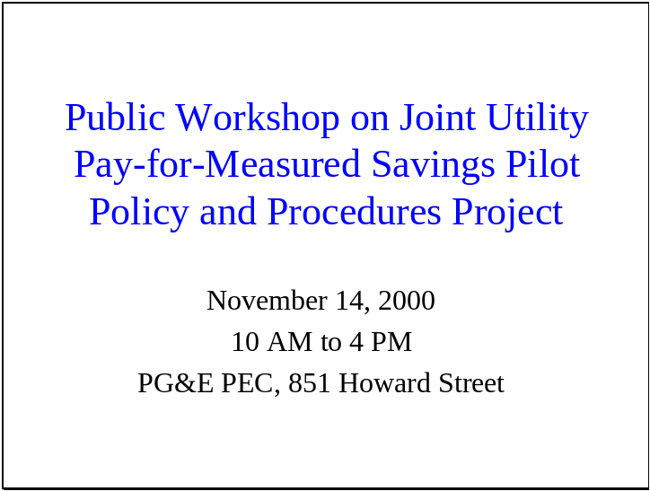

Slide 2

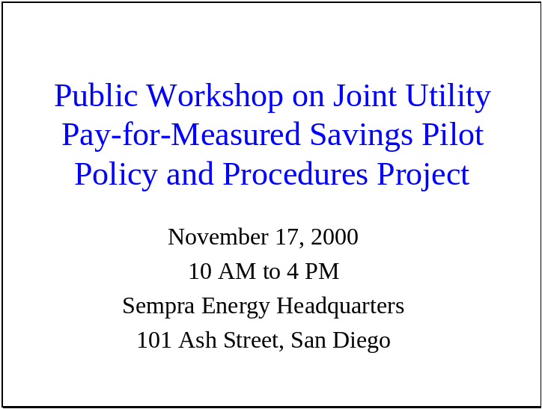

Slide 3

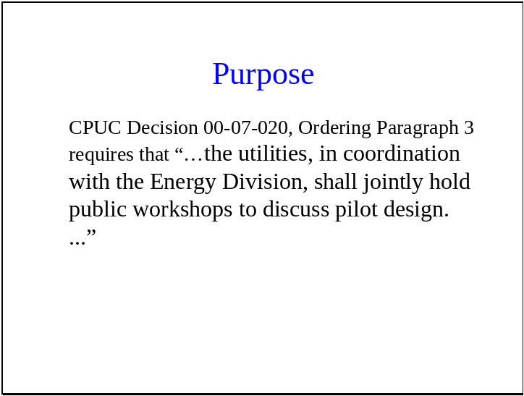

Slide 4

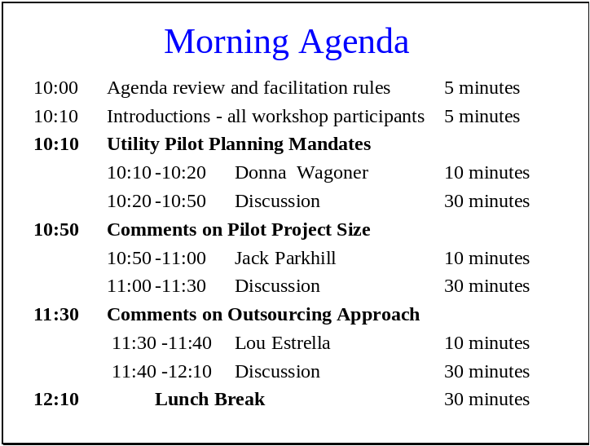

Slide 5

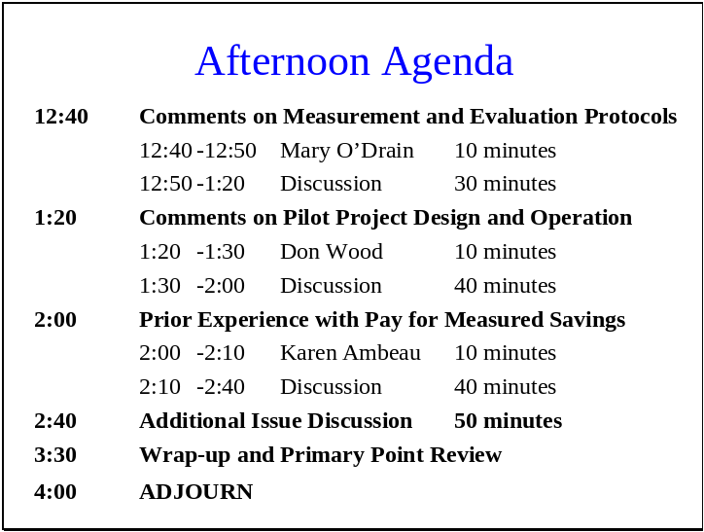

Slide 6

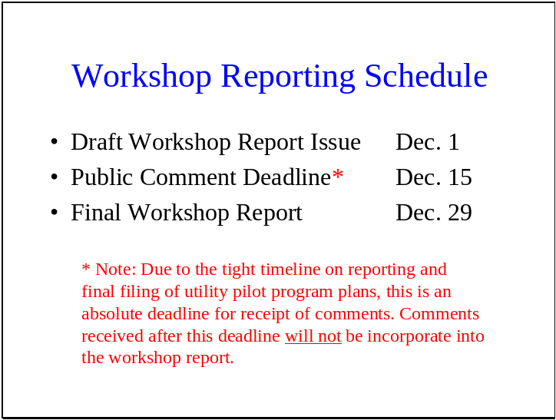

Attachment D
Program Presentation Slides
Slide 1 – Pilot Size Topic

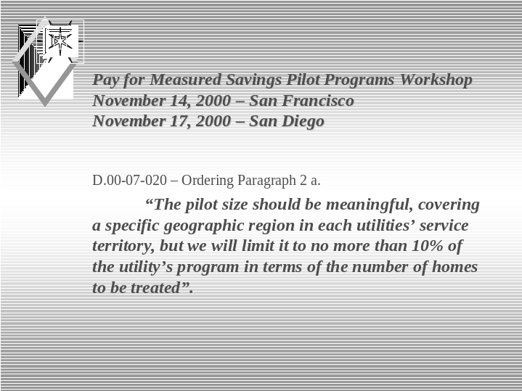

Slide 2 – Pilot Size Topic

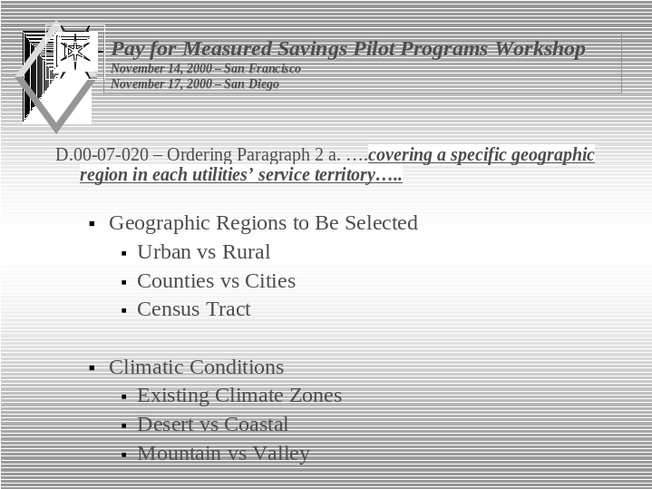

Slide 3 – Pilot Size Topic

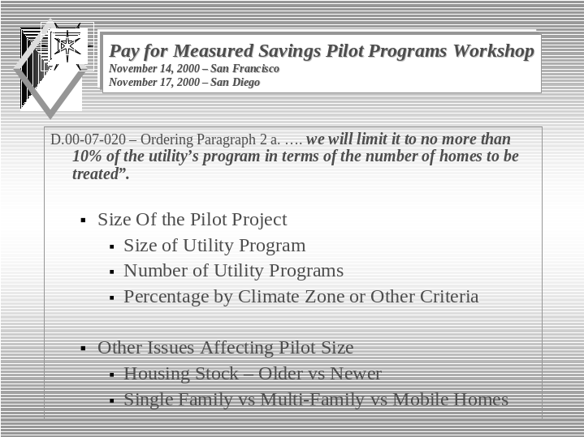

Slide 1 – Outsourcing Topic

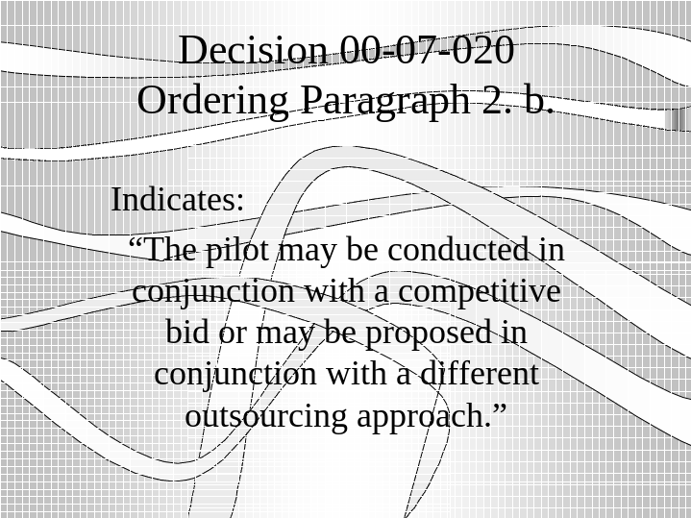

Slide 2 – Outsourcing Topic

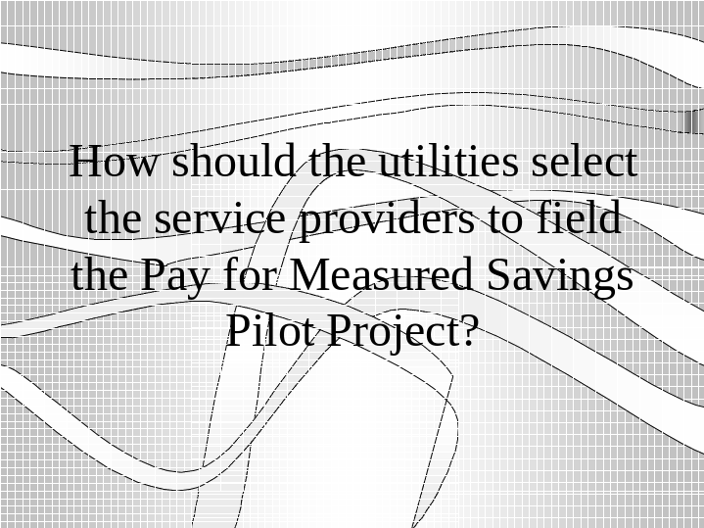

Slide 3 – Outsourcing Topic

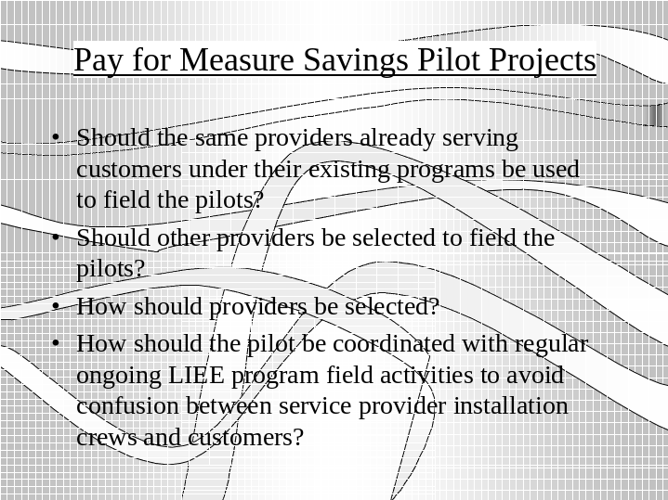

Slide 1 – M&E Topic

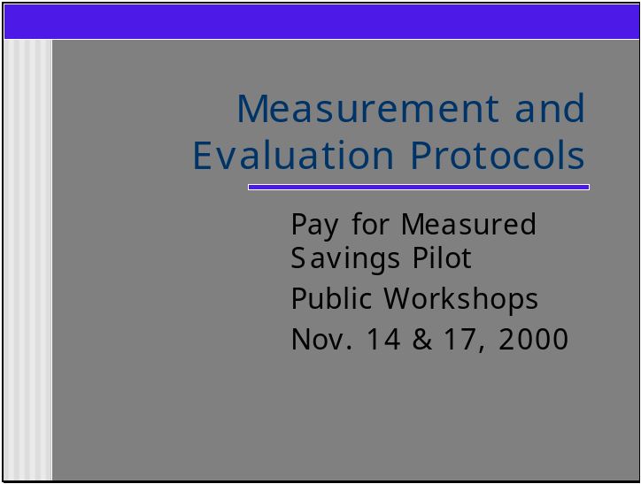

Slide 2 – M&E Topic

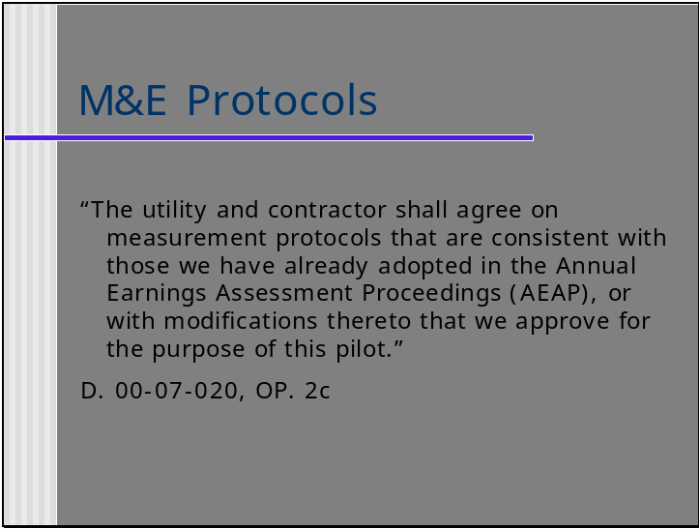

Slide 3 – M&E Topic

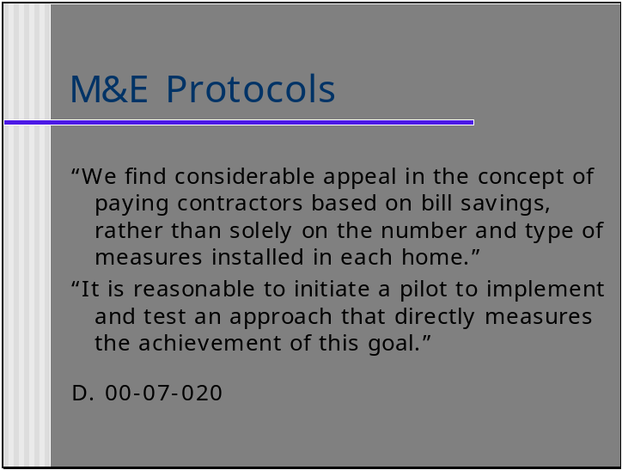

Slide 4 – M&E Topic

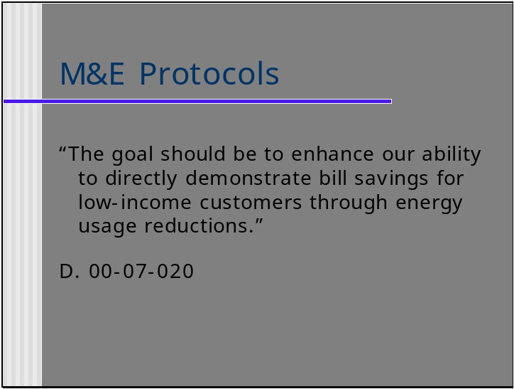

Slide 5 – M&E Topic

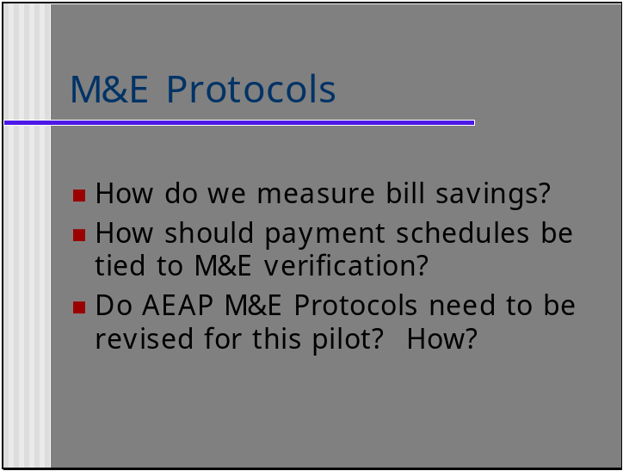

Slide 6 – M&E Topic

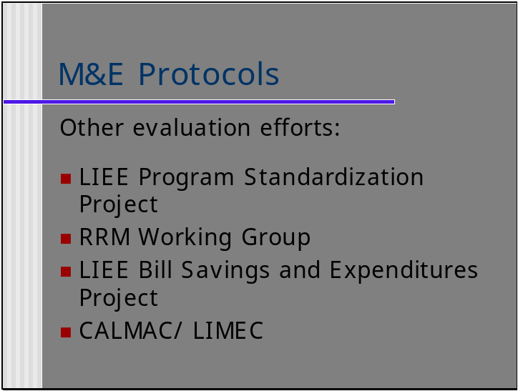

Slide 1 – Prior Experience with pay for measured savings Topic

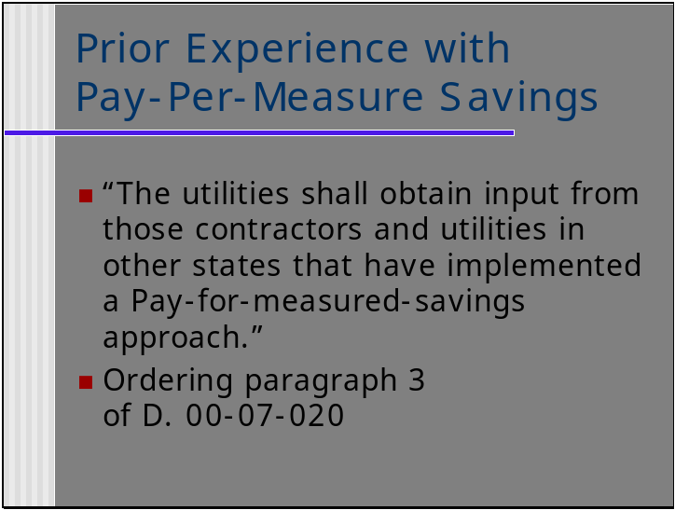

Slide 2 – Prior Experience with pay for measured savings Topic

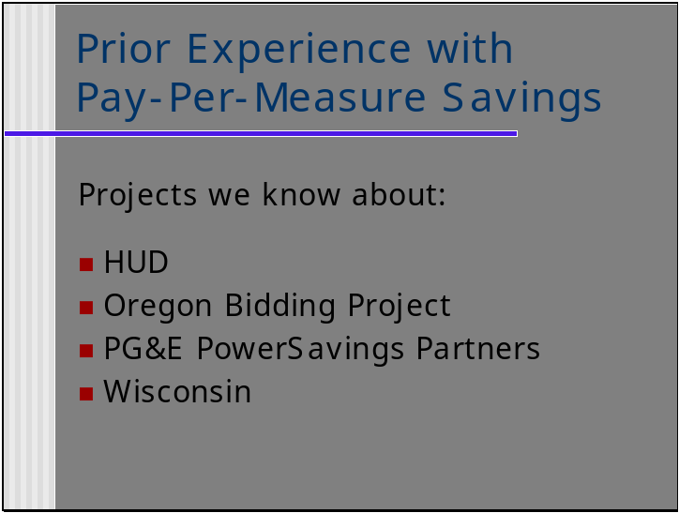

Slide 3 – Prior Experience with pay for measured savings Topic

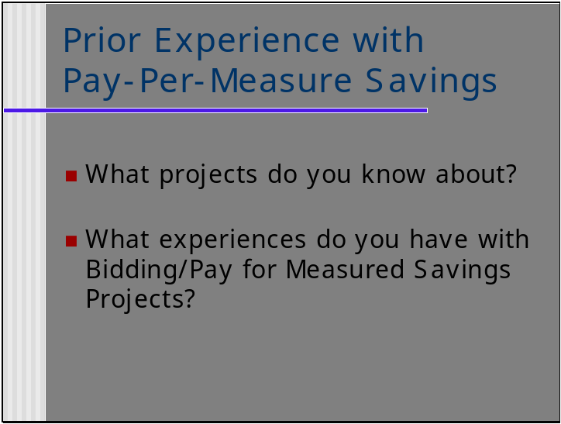

Attachment E
Workshop Handouts

To obtain copies of the tapes for this workshop contact Margee Moore at Sempra (mmoore@sempra.com).
The following utilities form the Joint Utilities group: Pacific Gas and Electric Company, San Diego Gas & Electric Company, Southern California Edison Company and Southern California Gas Company.

